Magic Invitational Report: Ben Rubin
Ben Rubin
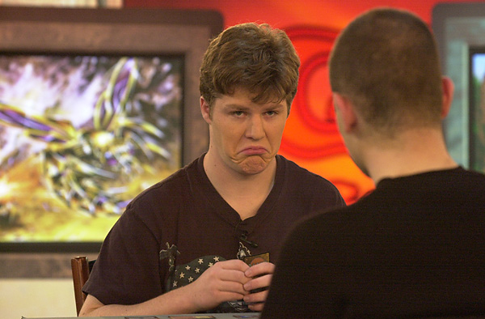
I must say, that of all of the places I have been to play Magic, Sydney was the finest. The hotel we stayed in was right next to the harbor and with the overcast weather we experienced I felt right at home (San Francisco is also near a harbor and often foggy). I was also pleased that I wasn't resented by the Australians just for being American. In general, people were very friendly, although they wouldn't let me in the hotel casino.

I like cards that will all work together for the common good without the chance of being useless...
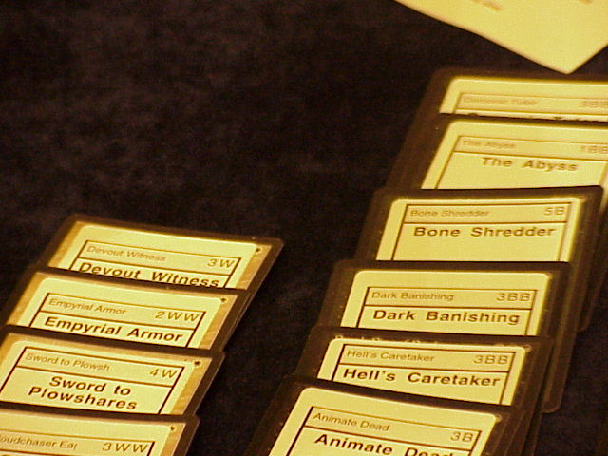
More importantly, I had a very good time playing Magic. First of all, I appreciate the recognition I received in the voting and hope that I didn't disappoint. Our tournament began with Duplicate Sealed. I had hoped that there would be an easy link to the options for the card supply. Needless to say, there were MANY different ways to run it. I chose to play green, white and blue, ensuring that my Winter Orb would be extremely good. I felt that green was the best color because of Wild Mammoth (G1 for a 3 / 4 that can be lost) and Maro (G4 as its new casting cost), so I was certainly including that. White and blue also had cards I like, versatile and powerful. Many players went for more aggressive strategies, or tried to fit combos like Hell's Caretaker, Tombstone Stairwell, Survival of the Fittest and stuff. I like cards that will all work together for the common good without the chance of being useless (as certain high potential cards have a tendency to be). My favorite cards, in addition to the ones previously mentioned, were Waterfront Bouncer (U3), Swords to Plowshares (W4), Cloudchaser Eagle (WW3) and Exclude (U3). When can these cards be bad? There was only time was when my 3-color strategy meant I didn't have mana of all 3 colors (this didn't happen so often as I was playing 19 lands and the games always went long). I was able to beat Noah Boeken and Bob Maher's Green/Red/Black decks almost solely on the strength of Winter Orb. Their decks just could not handle the strain while mine could. One must remember that the spells in our environment cost an amazing amount of mana to cast. I did not choose to play with Tetravus (8), Triskellion (8)or Herald of Serra (priced at WW4) in hopes that my deck might be as fast as possible. Without as many fatties, I left the Black Lotus out of my deck, even though it might have been good with the Winter Orb. Jon Finkel beat me in a pretty close match by having Aladdin (2RR) and the Blacksmith (2R) to stop my Tawnos' Coffin and Mishra's War Machine which would have beaten him in game 2. His deck was faster than most because he avoided playing Black, probably the right call. In game 3, he played turn 2 Groundskeeper, turn 3 Goblin Bombardment, turn 4 Living Plane. THAT is a lock. So after 3 rounds I was 2-1.
The next format should have been great for me as I love block constructed. Unfortunately my deck had that homebrewed feeling and was pretty untuned. I played a Counterphoenix deck:
Counterphoenix
Main Deck |  | Sideboard
4 Tradewind Rider  4 Legacy's Allure  4 Counterspell  4 Forbid  2 Mogg Fanatic  4 Intuition  4 Shard Phoenix | 1 Mana Leak  4 Hammerhead Shark  2 Whispers of the Muse  4 Reflecting Pool  14 Islands  9 Mountains | 3 Dismiss  3 Mana Leak  4 Wasteland  4 Chill  1 Grindstone
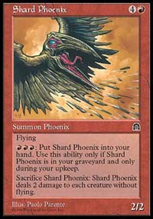
I had Tempest/Stronghold/Exodus. I DEFINITELY should have played Alliances over Exodus. I considered this change until the last minute but felt Forbid/Phoenix to be too powerful to pass up. The cards that would have been added to the main deck and sideboard are: Pillage, Force of Will, and Burnout. While none of them are stars in the main deck, Pillage would have been a valuable anti-artifact measure. Burnout and Force of Will would also have given be the advantage in any matchup in which large counter wars were likely. Force of Will happens to be worse in this deck than in the usual control deck because of the high land count and the need for every spell to count. My only testing of this deck was against Ponza and I was quite successful. Unfortunately, Alex Shvartsman's red deck (in round 4) was all beats and I died very quickly. Lava Hounds and lots of burn to back up his Pups were way too much when I was forced to clear the board with Phoenix. My next match was with Gerardo Godinez who WAS playing Ponza. I must say that this match was not pretty. First game I cleared the board with Phoenix and had a wall of counters for any other threats. Second game things got Chilly for him (I pulled the Phoenixes) and he couldn't overcome my Sharks, Allures and Tradewinds. My final match of the day was against Trevor Blackwell, sporting Mike Long's Ponza deck. I must say that their deck was quite good, an aggressive and disruptive deck (Pups and Stone Rains) backed up by monsters like Phyrexian Warbeast and Balduvian Horde. The match went to three games but his Ghitu Encampments and Beasts were too much in the end.
My match score: 3-3.
Next format was my personal favorite: Solomon Draft. Only Mental Magic gives a player more options during the match (the Solomon Draft is part of the match). First round I played Darwin Kastle, a man who seems to have played the format more than the average competitor. He wins the flip and has me make piles first. I gladly open up the first pack and immediately we see the theme: GOLD. Every card was either a split card, gold card, Invasion dual land or cameo. Seemed fairly lame to me, it was impossible for a player to make a really consistent deck if the drafter opposite him was doing a decent job. Darwin and I have very different philosophies on Solomon Draft and it became pretty obvious early on in the draft. An interesting problem in this particular draft was the oddity of the draft and the short time players were given to divide the piles. One pack I divided into piles that I felt were very far from equal (what was in each pile exactly escapes me) which I could have done a better job on if I had had more time. Darwin ended up choosing the WEAKER of these two piles. It seemed to me that he was trying to sacrifice quality in an attempt to get me spread out in the draft (with strong cards in each color while he would have a weaker but more consistent deck). His plan did not work in, my opinion, as we both ended up playing 4 colors and lots of mana producers (I think I ended up playing 19 lands and 2 Cameos). In this draft I committed the error of undervaluing the Forestwalking U/B creatures and I almost lost to them. As far as dual mana producers, we both valued them pretty highly and ended up splitting them fairly evenly. I ended up winning a long and tight 3 game match on the strength of Energy Bolt and Reckless Assault.
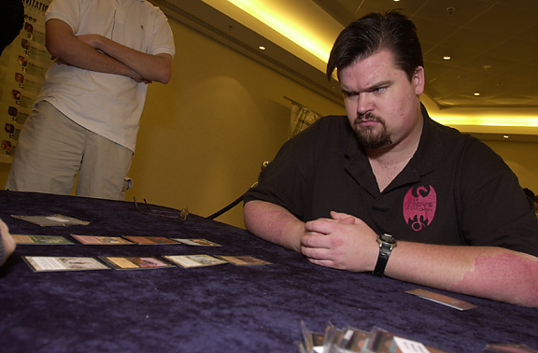
Next draft I played Kai Budde. Kai was at this point 0-7 and although I was rooting for him to salvage some respect; I expected to win. This was the draft of legends as well as containing some Fertile Ground type cards. I ended up with the Galina (UU3 1/3, tap to take control of target legend) and the Sisay (searches library for a legend to put into hand). I felt a little bit more comfortable in the draft than I think Kai was and I took the match 2-0. Galina ended up doing quite a bit in both games.
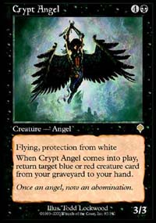
Next round I was paired against Zvi. Zvi had also had a tough weekend so far and we had a pretty interesting draft. We caught on about the same time that the draft was all about color interactions. I ended up with the Sway of Illusion, Tidal Visionary and Whim of Volrath to his Slight of Mind. I felt that the rest of my deck was pretty naughty and the only card I feared out of his deck was Karmic Guide (I was U/B/R and he was U/G/W). Many players in this round felt that the Grindstone was too good for the format because there was no artifact removal. In my opinion the Grindstone was way too slow for the decks that Zvi and I ended up with. If a player has time to spend 3 mana on most of his turns in order to grind his opponent then his control of the game is probably sufficient to win the game anyway. The milling strategy also cannot be complemented by creature damage so I ignored it all together. Instead, I used my very large creatures and spells (3 Djinns, Barbed Back Wurm, Crypt Angel among others) to ram through his defenses and win pretty easily. My record: 6-3.
The next set of rounds was the Auction of Champions. I had thought about the format and came to a few conclusions. My first conclusion was that none of the decks, with the possible exception of Maher's, could go below 6 cards-15 life and still be worth drafting ahead of Olle's deck (the baseline deck that I assumed the 16th person would end up with). The exception to this rule would be, for example, if I knew I had a chance to play against 2 or 3 of the Tinker decks then I might go to 6-14 or 6-13 for Champheng's deck (8 artifact removal after board). The deck I wanted most was, in fact, Champheng's deck because he happened to have great matchups vs. the artifact based decks and because his quick creatures, backed up by Strip Mines/Plows/Disenchants, would be perfect against decks starting with less than 20 life and less than 7 cards. Another deck I was willing to play was Dave Price's deck if I could get it with 7 cards. During the draft, Mike Long and Gary Wise ended up with the 2 strongest decks but neither ended up getting a win. This makes me feel like my rule of thumb for drafting decks was somewhat accurate- these players both dropped below 6-15 (Mike to 5-19 and Gary to 6-13).
As the bidding went, I ended up with Dave Price's red deck at 7 cards- 13 life. I think I got the 5th best deal in the draft and since my opponents were playing decks that were pretty vulnerable to Dave's deck, I was satisfied. Based on their performances and relatively modest bids, I think that Jon Finkel (Dolan's Type 1 deck at 7,17 - he smashed me), Chris Pikula (Oath at 6,15- I beat him), Gerardo Godinez (WW and played against Tinker twice), Kai Budde (his own deck at 6,20) were the favorites coming out of the draft.
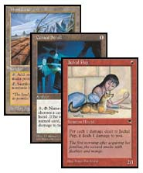
In my first round I played Mike Long, he was with Tommi Hovi's deck. In game 1 I went first and with many 1-casters and a Wasteland I put the pressure on. With damage coming at him pretty quickly, he couldn't get the resources ready to go off past my Wasteland. Ancient Tomb showed its ugly head as a bad long term mana source against a deck as fast as Deadguy Red. His sideboarding plan was to add the Wastelands and a few Gorilla Shamans and take out a Tomb, Power Sinks and Abeyances. This meant not adding Chill, the card I was most afraid of. It is true that my deck had no Pyroblasts, so in that way Chill was not necessary for him, but with the ability to make first turn Chill, it seemed like he almost had to put them in. Instead he felt that drawing first and making sure that he had the best chance possible to succeed in going off was worth leaving the Chills out. In game 2 he was successful in going off. Game 3 I had enough Shatters, Stone Rains, Wastelands to keep him from having any chance at going off. The deck I played had:
Main Deck |  | Sideboard
4 Jackal Pup  4 Mogg Conscripts  4 Mogg Fanatic  4 Mogg Raider  4 Cursed Scroll  4 Canyon Wildcat  4 Giant Strength | 4 Fireslinger  4 Kindle  2 Scalding Tongs  2 Rathi Dragon  4 Wasteland  16 Mountain | 4 Stone Rain  4 Shatter  1 Rathi Dragon  1 Apocalypse  1 Torture Chamber  2 Jinxed Idol  2 Scalding Tongs
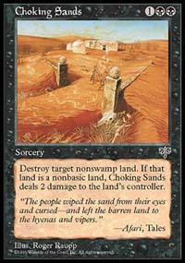
Against Long I pulled the Scrolls, Dragons, Fireslingers in favor of 2 Tongs, 4 Shatters, 4 Stone Rains (I wanted Tongs to keep the pressure up even if he got Chill - although Chill might put me at 4 cards in hand rendering the Tongs useless). Next match I played Ishii who had Jakub Slemr's 5color black at 7 cards 18 life (may have been 19 or 17 life). I felt very good about my chances against him because his mana base is very susceptible to Wasteland/Stone Rain and my Scrolls could win the game single handedly if he is denied green and white mana. Ironically he won the first game with Choking Sands. I had kept a 1 land hand because of all of my 1-casters and simply never drew a second Mountain after he killed my first. Next game he played Black Knight after Black Knight and then finished me off with 3 Incinerates (I started the game at 13).
My next match was against Chris Pikula. In the first game I came out fast and he simply couldn't find an Oath fast enough. In game 2 he actually ended up having Powder Keg, Oath, and CoP: Red out all at the same time. However he was at 2 and with a Wasteland I killed his only untapped mana producer and then Kindled in response to his activation of CoP: Red. His starting life total (15) was obviously crucial in this match, but I'm not sure that I win this match most of the time. My record: 8-4

Ben Rubin found out he was in contention so he went back to his room to get his Pups.
After winning that match I was in contention and decided I had better make a good Type 1 deck. The deck I had been planning to play was Brian Weissman's The Deck. My preparation for the Type 1 portion had been a visit to the Weissman residence in order to get crushed by both of Brian's decks. The decks I had thrown together to play him were pretty untuned and my understanding of the format is/was decidedly insufficient. With some insights about Type 1 and what felt like a strong deck I felt prepared for the format. Unfortunately, after arriving in Sydney I had gotten some testing in against Bob, Chris, Dave, Mike and had not had a winning record against ANY of them. I'm not sure if luck, lack of experience, lack of ability or inferiority of The Deck is to blame for my failings, but clearly something had to change. The only option, with an hour to go before the Type 1 round, was to gather the trusty Pups and Bolts and hope I could be competitive. I overheard someone saying "Ben Rubin found out he was in contention so he went back to his room to get his Pups." They hit the proverbial nail on the head. What I ended up playing was:
Main Deck |  | Sideboard
4 Jackal Pups  4 Goblin Cadets  4 Lightning Bolts  4 Gorilla Shamans  4 Dwarven Miner  1 Wheel of Fortune  1 Time Twister  1 Demonic Consultation  1 Mind Twist  1 Yawgmoth's Will  1 Kaervek's Torch  1 Demonic Tutor  1 Time Walk  1 Ancestral Recall | 1 Mox Ruby  1 Mox Jet  1 Mox Sapphire  1 Black Lotus  1 Sol Ring  1 Vampiric Tutor  1 Mystical Tutor  1 Red Elemental Blast  4 Mishra's Factory  4 Wasteland  1 Strip Mine  4 Volcanic Island  4 Badlands  4 City of Brass  2 Sulfurous Springs | 4 Boil  2 Balduvian Horde  4 Cursed Scroll  4 Mogg Fanatic  1 Zuran Orb
The logic behind this deck is that although it can abuse most of the important power cards, it is very consistent and really overloads the opponent's creature removal. Many Type 1 decks seem to be very inconsistent in that they can be completely stunted by 1 Gorilla Shaman or Wasteland, that is not true for this deck. While I still think that my deck was pretty reasonable, my sideboard was admittedly awful. I planned to play against monoU (Gary Wise), Sligh (Dave Price), and some sort of aggressive deck (Ryan Fuller). My sideboard should have been chock full of Red blasts, Blood Moons and maybe even some enchantment/artifact removal, but I did not have the good sense to make it correctly.
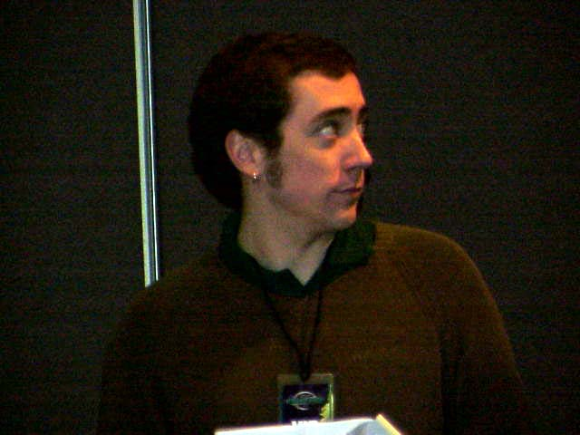
First round I played Dave Price who, surprisingly, stuck with his Mishra's Workshop deck. He had led me to believe otherwise and my sideboard certainly shows it. First game I killed many lands with a Dwarven Miner but he kept playing new ones. All the time I was getting hit by a Su Chi and eventually I had to block. I made a pretty horrendous mistake - instead of activating an old factory, I activated the one with summoning sickness so it couldn't pump itself(it would have been a 4/4). Therefore I had to block with the Miner as well. He killed the Miner and my land-smashing days were over. I'm not sure that the Miner was that much more valuable than the Factory at that point (I assumed that with the Su-chi mana he would have a new artifact monster for me), but giving him the option to kill the Factory was really bad. I lost the game a few turns later as I couldn't stop his big creatures while at 4 life. Next game he brought in a ridiculous number of sideboard cards (4 Bottle Gnomes, 7 Blue Blasts) while there was nothing especially good for me to bring in. I got in some early pressure and disruption with Gorilla Shaman and Wasteland until he was pretty low on life. He then shored up with Blasts and creatures and a standstill ensued. Fortunately I drew Yawgmoth's Will and had more than enough mana to Torch him out (I could have also protected it from counters). It all came down to game 3 and Dave had a pretty amazing draw. He played Workshop, Lotus, Sol Ring, Mox Sapphire to cast Juggernaut and Su-Chi with a Tinker remaining in his hand. All I could do was Bolt the Jug and say go. He attacked and passed the turn back. My draw wasn't particularly stellar but I slowly gathered some troops, including a Miner. On the turn of truth (when I was at 4 and he was going to attack with Su-Chi) Dave Tinkered, sacrificing his Sol Ring and I had the Red Elemental Blast. He then attacked and I didn't have the mana to activate factory anymore so my Miner chumped. I then drew a Kaervek's Torch and was able to Bolt/Torch the SuChi. With Dave down to a lonely Mox, I had taken control. He Hydroblasted my next creature but eventually a Gorilla Shaman and Wasteland wiped his board. Lethal damage soon took him down and I had won what had appeared to be the impossible game and match.
Next round I played Ryan Fuller. I had expected him to play an aggressive deck just because he seems to prefer them. He ended up playing a pretty classic Blue control deck with the gas from the other colors. Boil was pretty good against him but the match was very close. In game 1, I managed to kill a Morphling by nuking all of his Moxes and Bolting it a few times when he was down to 1 land untapped. My forces ran in at him, unopposed, after that. The first game after sideboard saw me Boil him twice while attacking with a Cadet. Unfortunately a Fact or Fiction had resolved and when he drew a Lotus for his Yawgmoth's Will he had plenty of juice to take complete control of the game. I'll casually mention that Yawgmoth's Will is absolutely ridiculous in Type 1, often taking someone from having nothing in play to having total control of the game. Game 3 he was able to stabilize until I got a Timetwister through and, with a new set of creatures and more mana, he could not keep up. My deck does very well at working with a fresh 7 cards. In retrospect, I probably should have included a Memory Jar without including a Tinker. Instead I included neither but, in reality, Memory Jar would have been plenty powerful, even at 5 to cast. My reasoning against this inclusion was that my opponents could probably cast spells during my Jar and at 5 mana it might be too slow to reliably cast before I got Mind Twisted/Wastelanded/Balanced/combo'd.
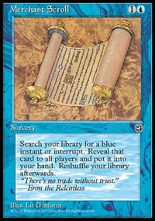
Homelands definitely has its moments...
In the last round before the finals I played Gary Wise. He completely broke my face open. With Merchant Scrolls and Fact or Fictions, Gary easily found his Abyss and made my creatures worthless (my deck has no enchantment removal). His Force of Wills and Mana Drains also kept me from doing anything type1ish to him and instead he got to draw many many cards. In addition to his strong base of spells, he had Underground Rivers and Factories so that my Boils were much less effective than expected.
With my loss, my record was 10-5 and I was barely into the finals against Jon. We (he) decided to put the Constructed formats so that if one of us (he) could win all of those we wouldn't have had to spend the time drafting and constructing decks for Limited. In retrospect, we should have played at least the Solomon Draft to perhaps entertain the spectators a little bit (I also felt that it was the format I was most likely to win). We were, however, more interested in playing basketball afterwards.

The finals:

So Finkel won. I can handle losing to him in the finals.
Auction was the first format and Jon's draws were just too good. It's possible that he has a substantial advantage vs. me but the games were pretty lopsided. Game 1 he made a first turn Serra (again I start at 13) and I really couldn't kill/race it. Game 2 he Copied my Cursed Scroll then Disenchanted it. After I had shattered his Scroll, he made a Serra and Cloned it. Again I was close to drawing dead and quickly died.
Match 2 was Type 1. First game Jon got one of those dirty Type 1 draws and I had no resistance. Game 2 I came out fast and killed many mana producers (Boil, Miner, Wasteland, Strip Mine, Gorialla Shaman) giving him very little chance at the game. Game 3 he simply locked it up. First a Moat then a Zuran Orb then a Circle of Protection: Red. At that point, my only possible way to win was to Kill ALL of his lands and Torch him for lethal damage (I had sided out my Bolts). Because he was at 18 and had many lands in play and cards in hand and I had nothing useful, I scooped em up.
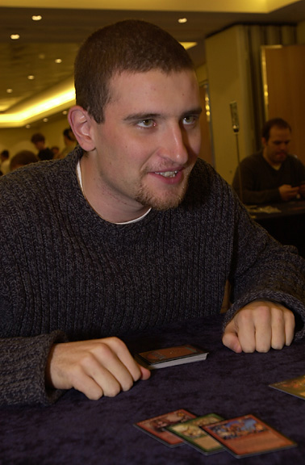
Match 3 was our closest. I won game 1, as I should most of the time, with Shard Pheonix recursion. I play more land than Jon and before sideboard he has very few good cards against me other than Masticore. With no clock, I had as much time as I wanted to wait and cast Shard Phoenix. Therefore the resolution of Masticore is quite unlikely and he is pretty much left to playing defense against Shard Phoenixes. After sideboard, he had Grindstones, which made my game a lot more difficult. Both games he got Allure advantage so I had to keep counter mana up for his Masticores. The reason is that once Masticore resolves I have no way to deal with him other than Tradewind Rider (pretty shady against Masticore, which can kill all of my creatures, and the Treacheries he might have had). I really kicked myself for not having Alliances (Pillage, Burnout) or at least Shattering Pulse or Capsize. So with the easy to force through Grindstones, Jon had a definite clock and I simply couldn't set up in time to kill him and defend against Masticore. So he won; I can handle losing in the finals.
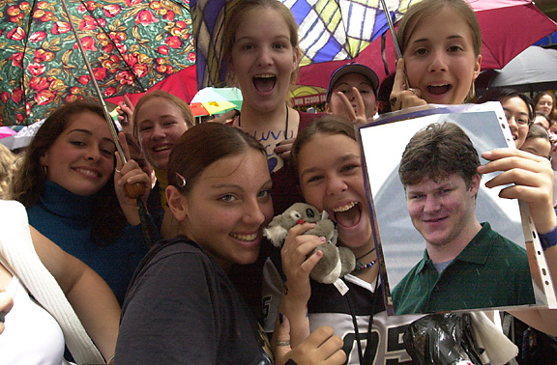
Outside of Magic I also had an extremely good time. Basketballing with the Magic players is sort of odd but many competitive games were assembled and I think that everyone involved had a pretty fun time. I was particularly surprised to see that, despite his well-roundedness, Worth Wollpert has some game. Eating out in Australia with the great people who attended this tournament was consistently enjoyable and I hope that people like Skaff and the Deadguys stay around Magic forever.
Thanks to:
- The many generous people who let me borrow cards- Brian Weissman, Mark Schick, TBS, Millionpointfireball.com and anyone/everyone who has ever let me use their cards.
- Mark Schick, Ken Ho, Morgan Whitmont, Brian Weissman (and any others) who are willing to help me prepare for tournaments whether it helps them or not.
- Mark Rosewater for constructing and running a very fun and interesting tournament.
- The good people at the Magic Invitational.
- Everyone who voted for me.
-Ben Rubin
Bendavejd@mindspring.com

